HYRS Male Volcano Plots

0.1_log2M

width = 13,

height = 5,

dpi = 400

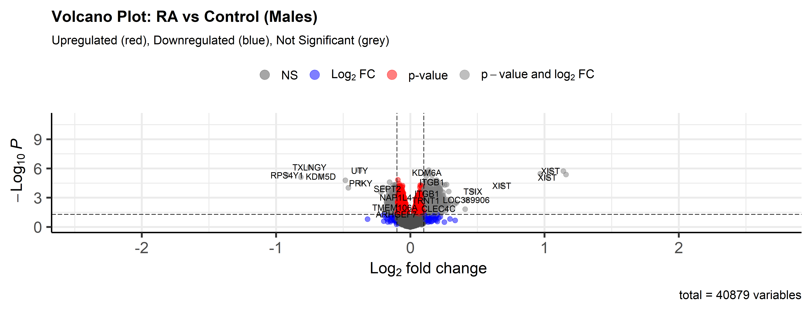

-clearer image with longer width and shorter height

width = 7,

height = 10,

dpi = 200

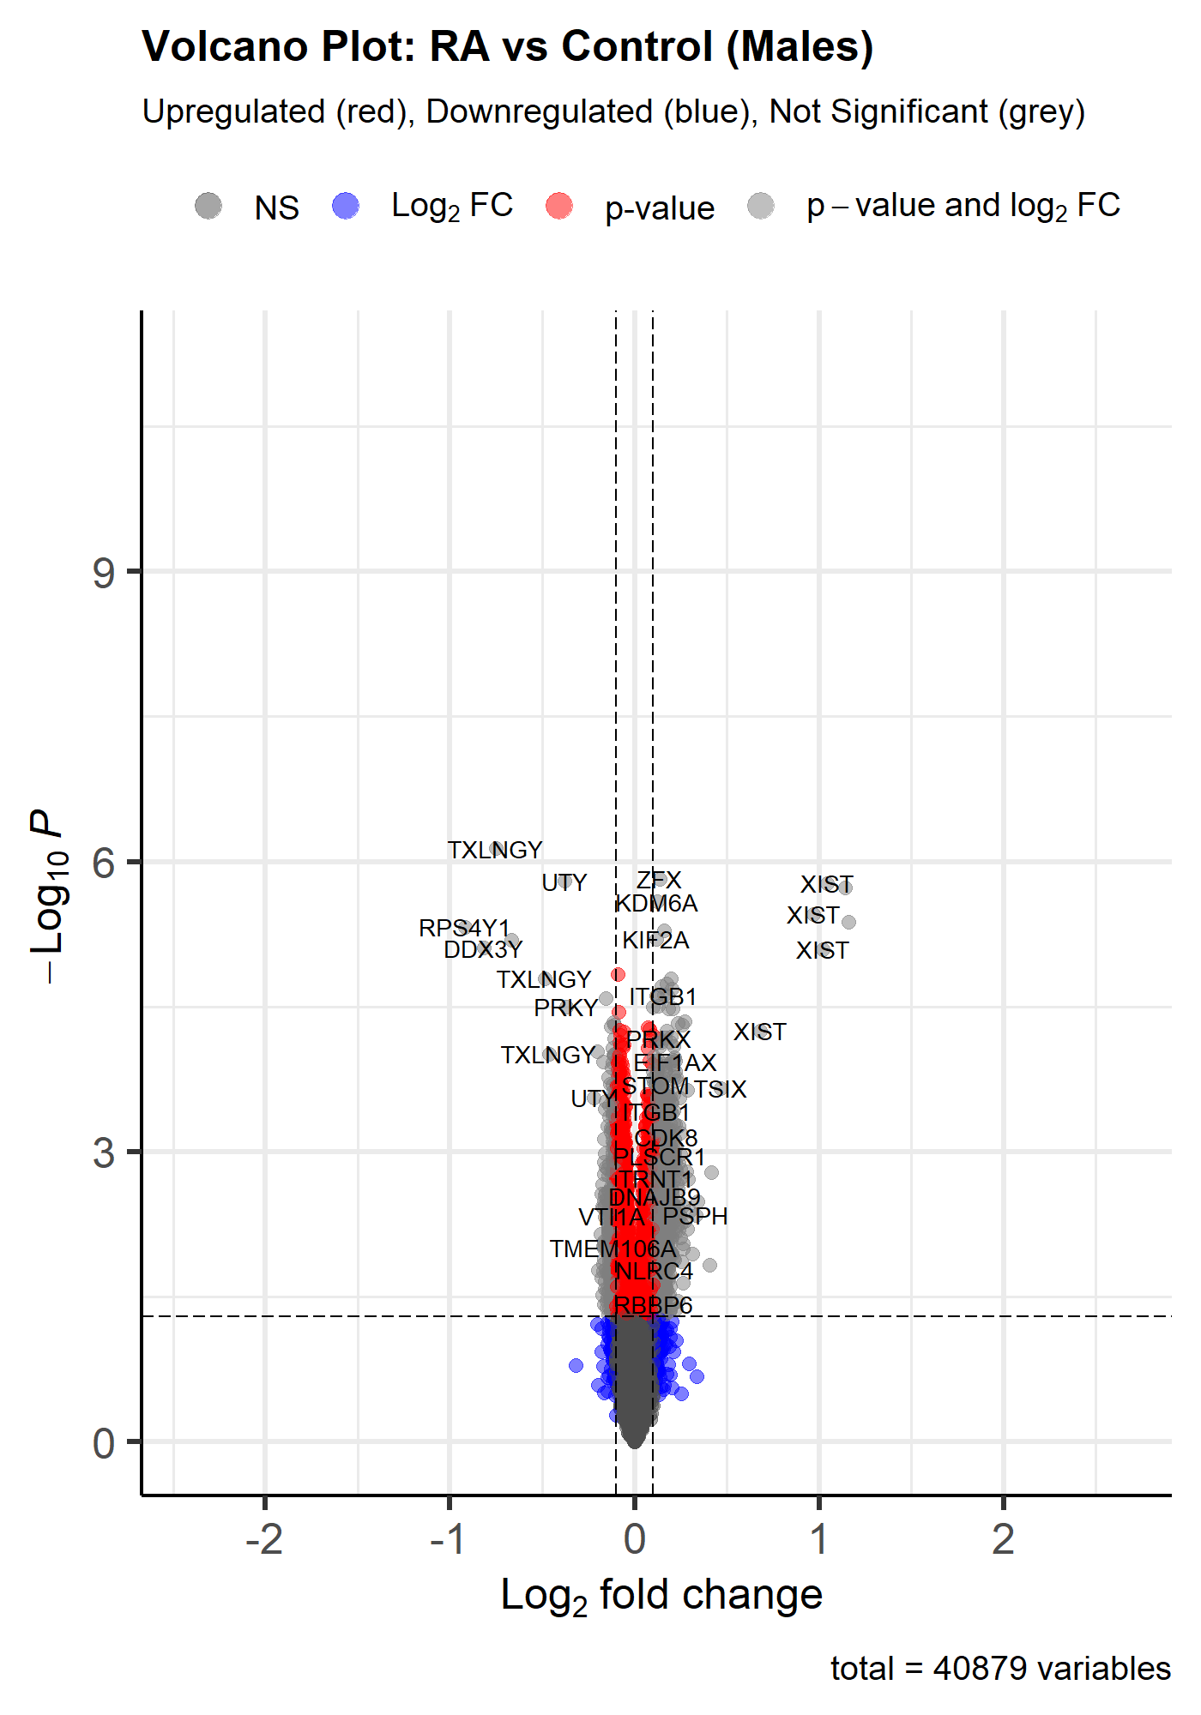

-less clear image, lengthened height and shortened width

4.2:

col=c('black', 'black', 'black', 'red3'),

colAlpha = 1)

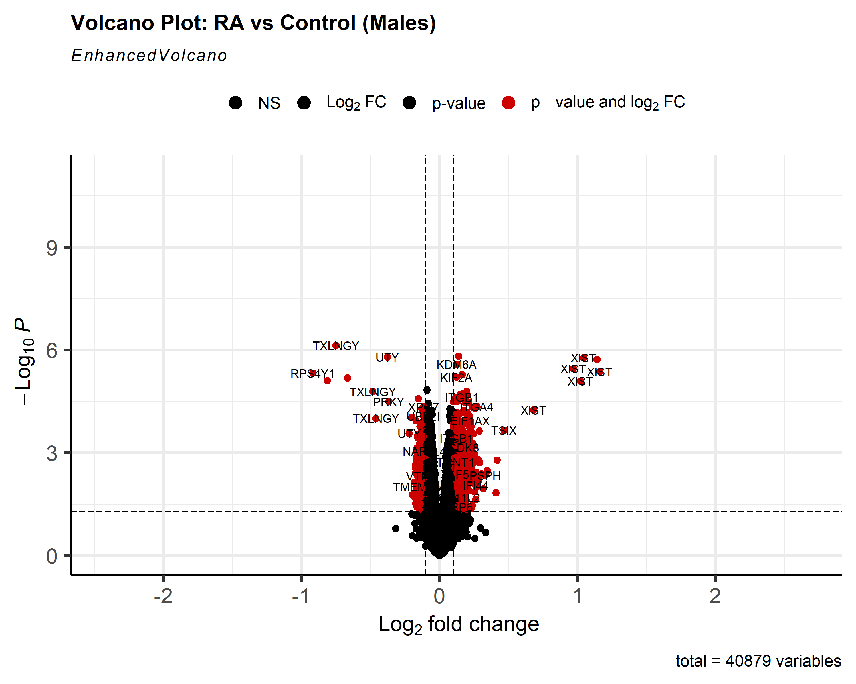

-standard length and width, clear image, color has changed to red and black (everything nonsignificant is black, everything significant is red)

4.3:

shape = c(1, 4, 23, 25),

colAlpha = 1)

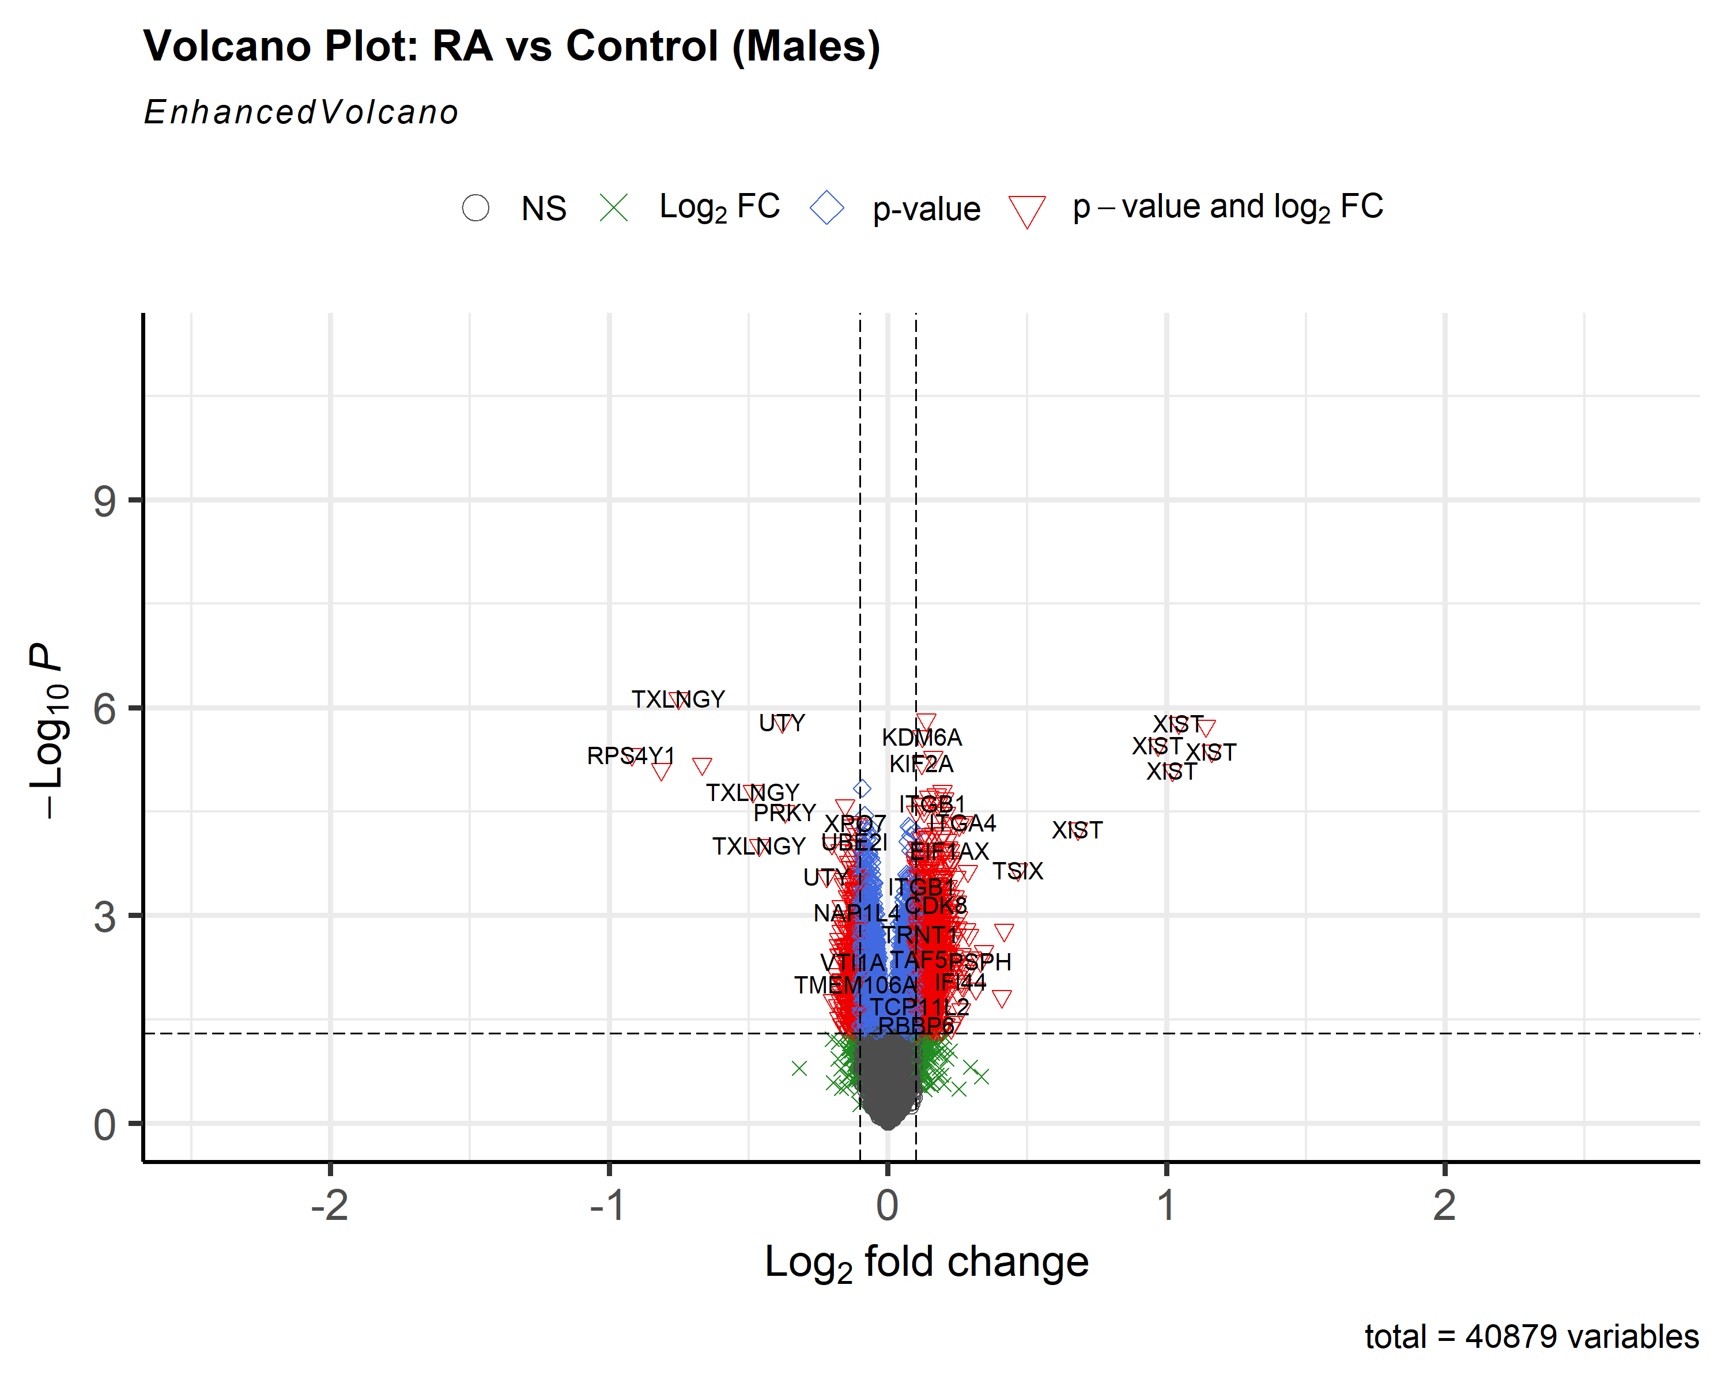

-adjusting shape of different types of significant values to identify them more clearly using the ggplot2 shape reference guide

4.4:

colAlpha = 1,

cutoffLineType = 'blank',

cutoffLineCol = 'black',

cutoffLineWidth = 0.8,

hline = c(0.05,

0.01 * 0.02,

0.01 * 0.03,

0.01 * 0.04),

hlineCol = c('pink', 'hotpink', 'purple', 'black'),

hlineType = c('solid', 'longdash', 'dotdash', 'dotted'),

hlineWidth = c(1.0, 1.5, 2.0, 2.5),

gridlines.major = FALSE,

gridlines.minor = FALSE)

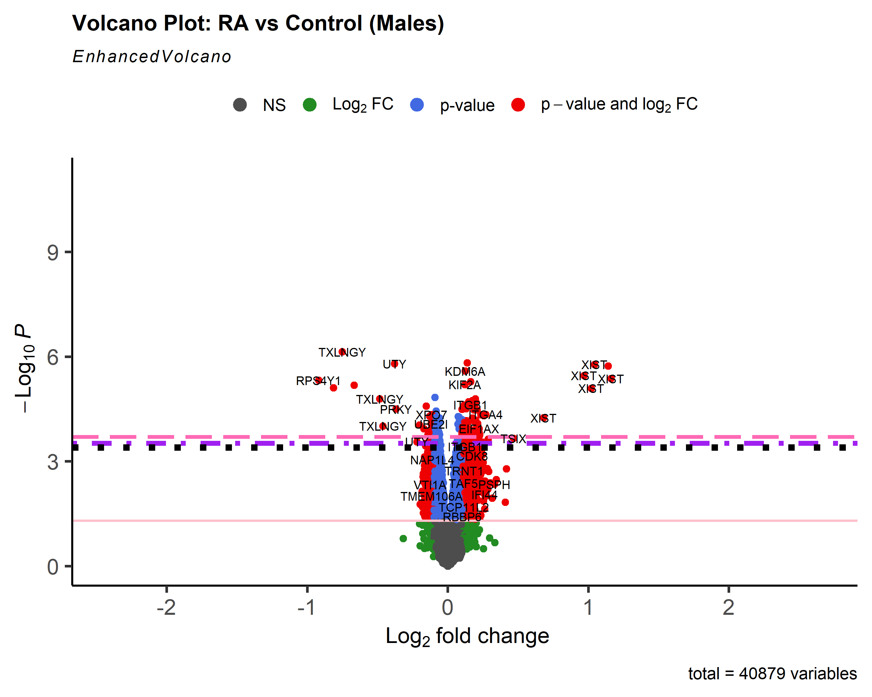

-experimenting with different threshold lines, changing their pattern and color

4.5:

cutoffLineType = 'twodash',

cutoffLineWidth = 0.8,

colAlpha = 1,

legendLabels=c('Not sig.','Log (base 2) FC','p-value',

'p-value & Log (base 2) FC'),

legendPosition = 'right',

legendLabSize = 16,

legendIconSize = 5.0)

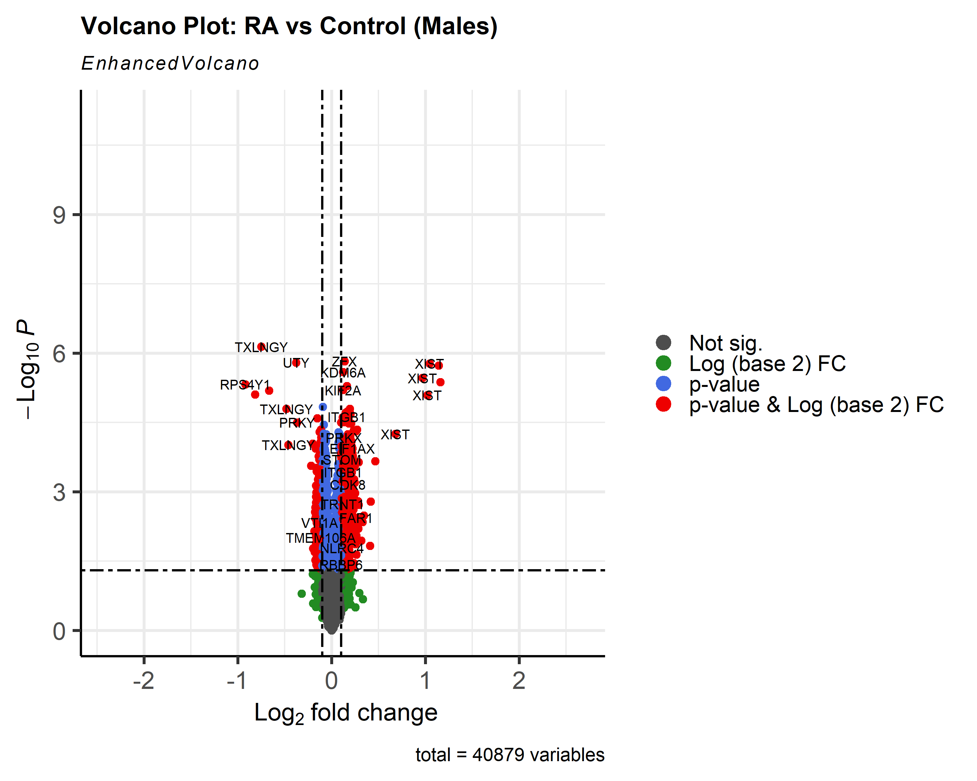

-changing legend labels and its position on the graph

4.6:

colAlpha = 1,

legendPosition = 'right',

legendLabSize = 12,

legendIconSize = 4.0,

drawConnectors = TRUE,

widthConnectors = 0.75)

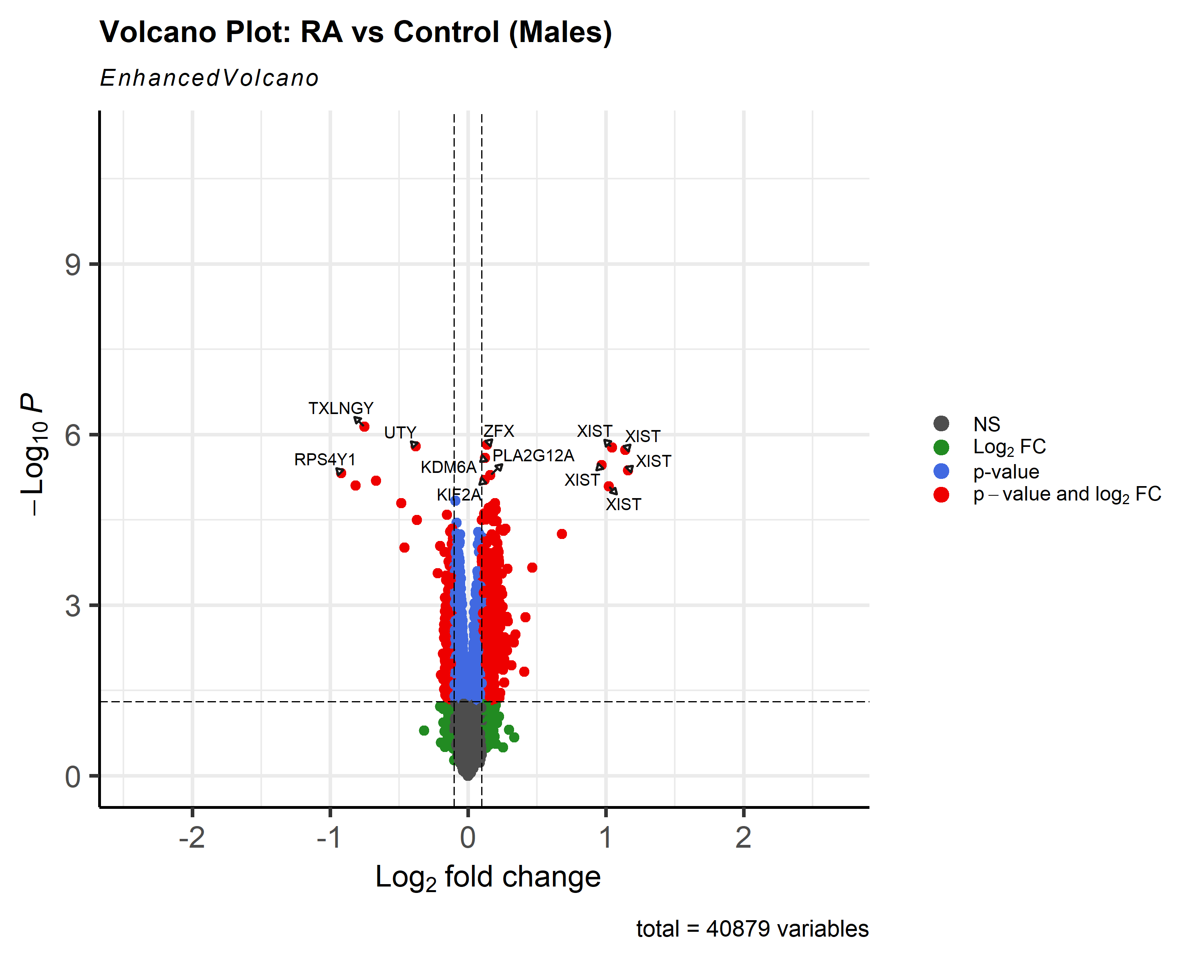

-adding connectors to genes and their gene symbol labels to allow for more labels to be present (however, this adds to a more crowded look)

4.8:

labCol = 'hotpink',

labFace = 'bold',

boxedLabels = TRUE,

colAlpha = 4/5,

legendPosition = 'right',

legendLabSize = 14,

legendIconSize = 4.0,

drawConnectors = TRUE,

widthConnectors = 1.0,

colConnectors = 'black')

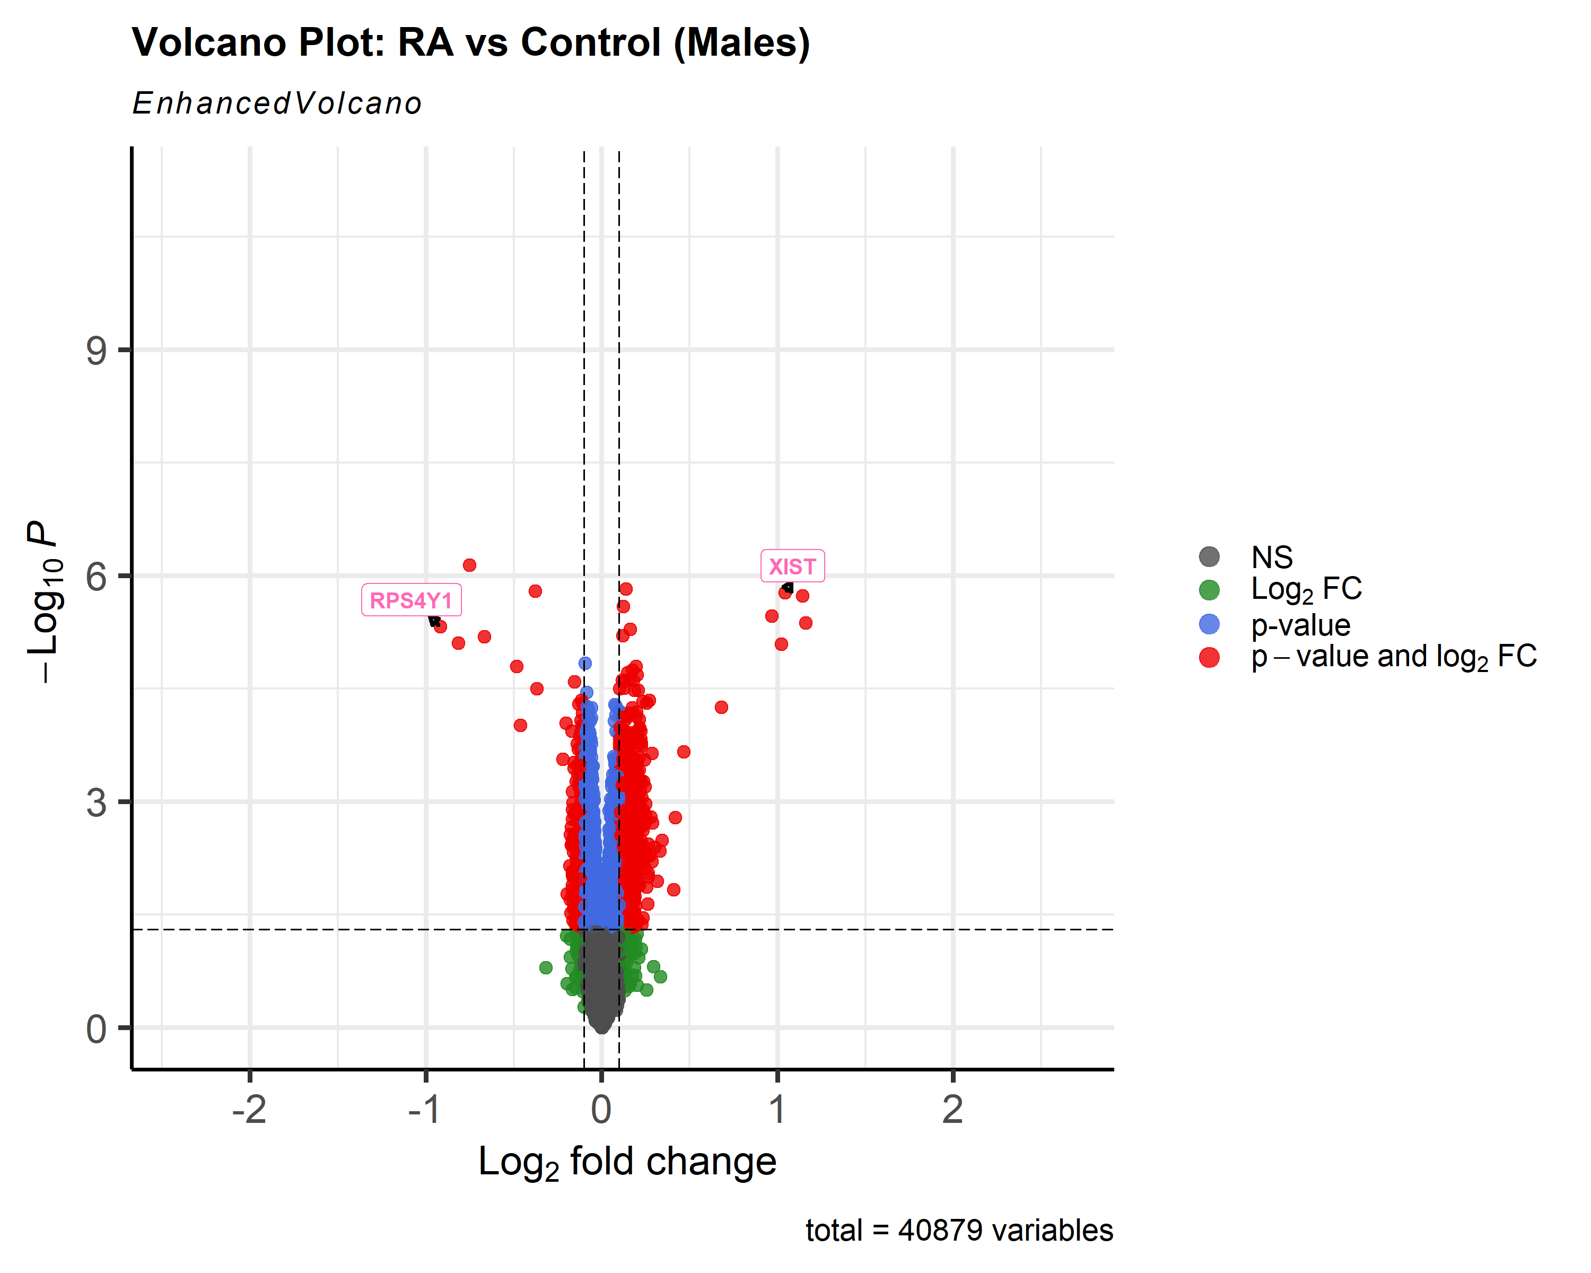

-changing label and connector color

4.9:

labCol = 'black',  
 labFace = 'bold',  
 boxedLabels = TRUE,  
 parseLabels = TRUE,  
 col = **c**('black', 'pink', 'purple', 'red3'),  
 colAlpha = 4**/**5,  
 legendPosition = 'bottom',  
 legendLabSize = 14,  
 legendIconSize = 4.0,  
 drawConnectors = TRUE,  
 widthConnectors = 1.0,  
 colConnectors = 'black') **+** **coord_flip**()

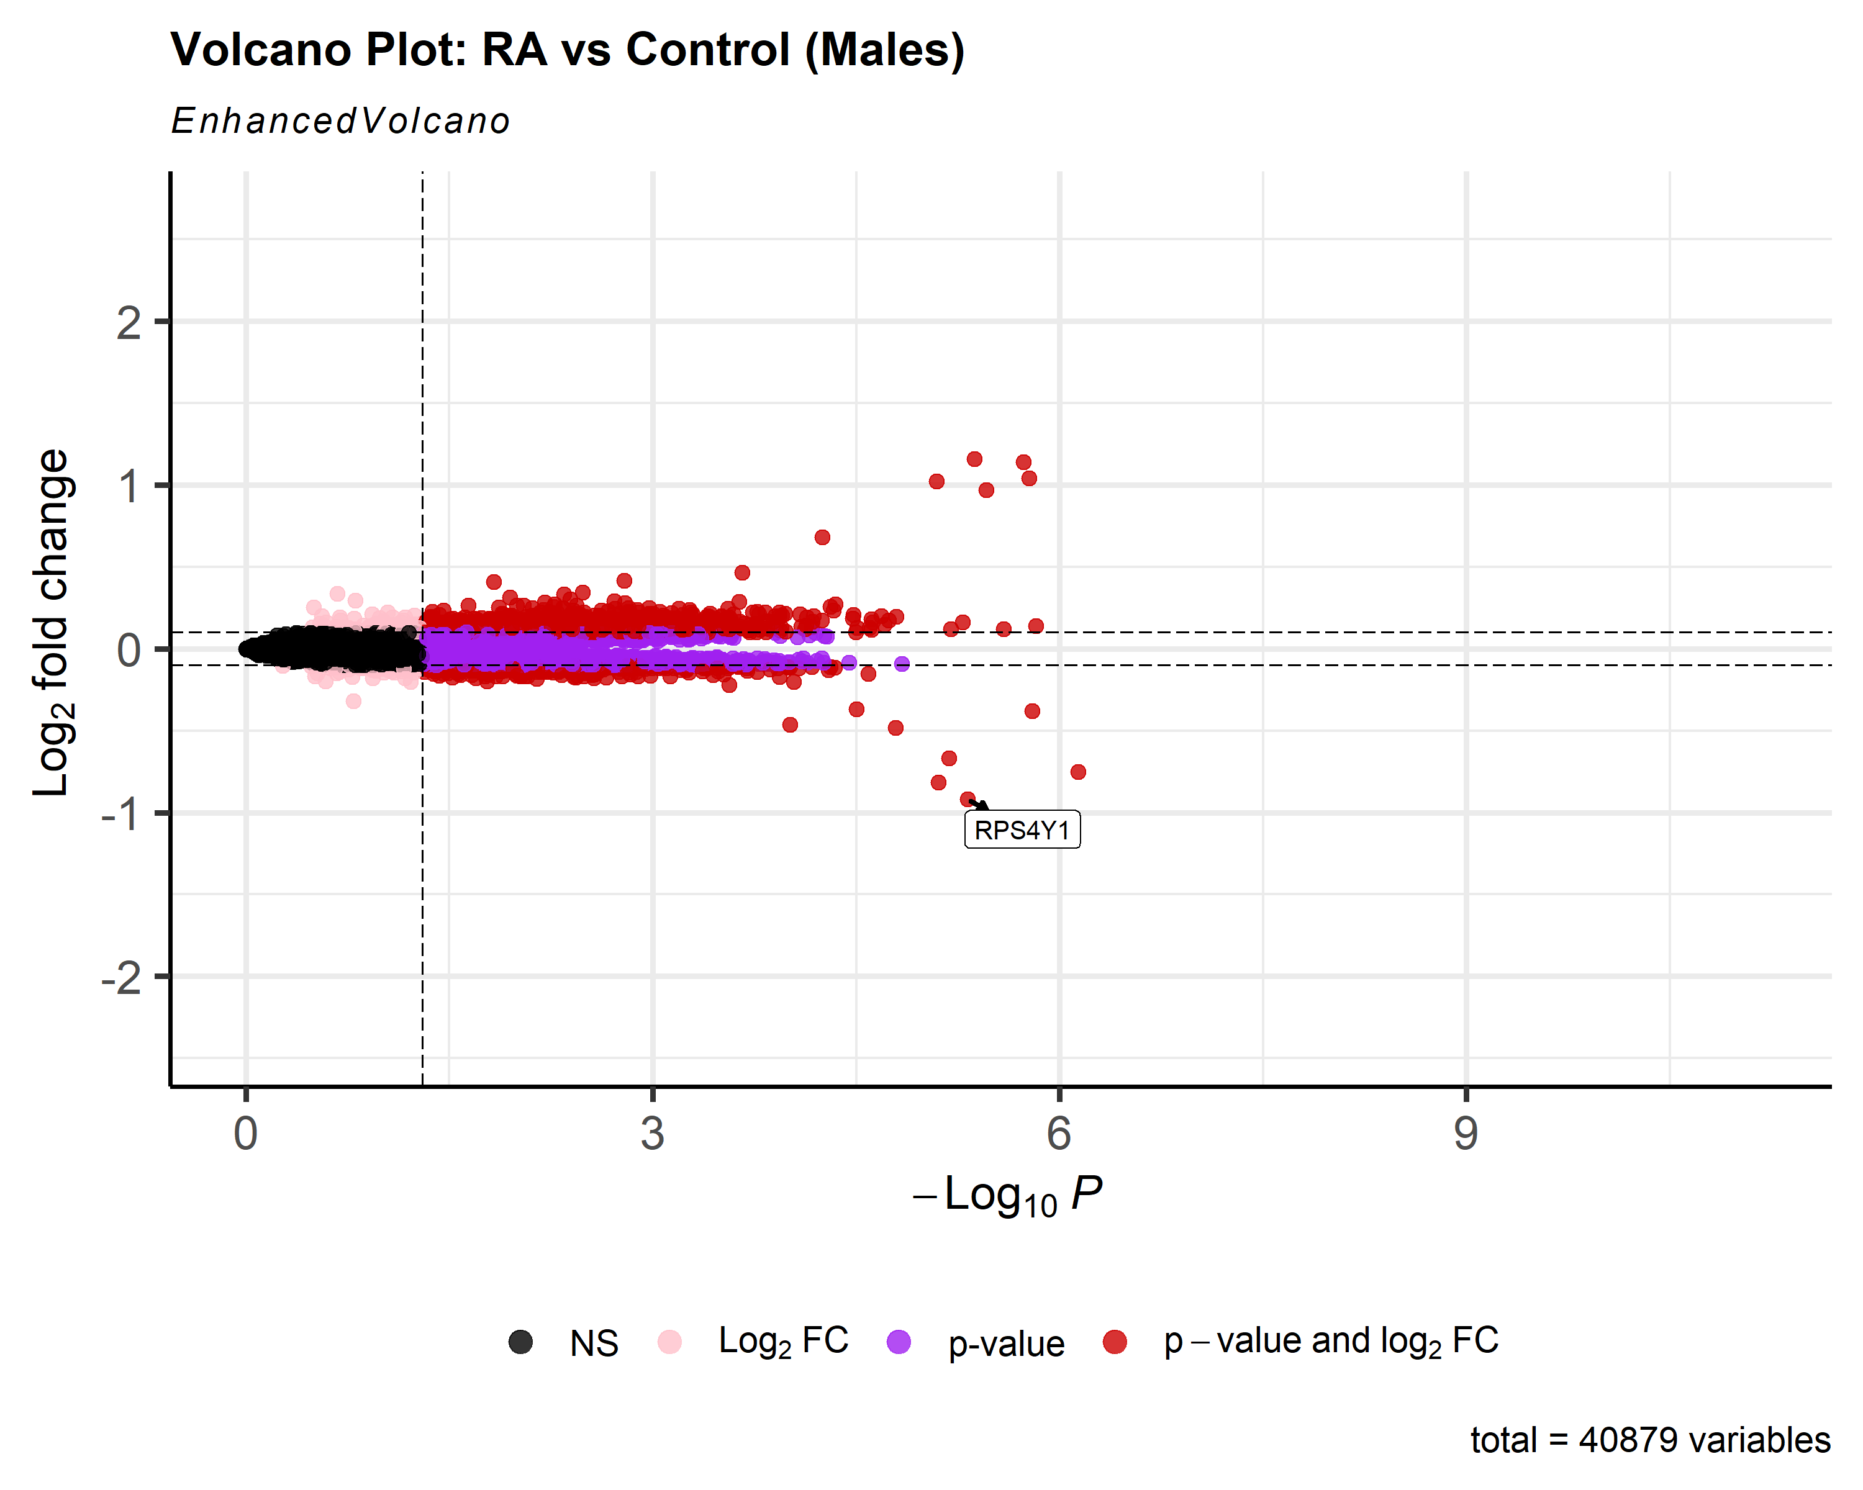

-flipping volcano on its side for a different view, and changing color of significant vs non-significant genes represented by dots

4.10:

keyvals <- ifelse(

data$logFC < -0.1, 'royalblue',

ifelse(data$logFC > 0.1, 'gold',

'black'))

keyvals[is.na(keyvals)] <- 'black'

names(keyvals)[keyvals == 'gold'] <- 'high'

names(keyvals)[keyvals == 'black'] <- 'mid'

names(keyvals)[keyvals == 'royalblue'] <- 'low'

selectLab = rownames(data)[which(names(keyvals) %in% c('high', 'low'))],

xlab = bquote(~Log[2]~ 'fold change'),

shape = c(6, 4, 2, 11),

colCustom = keyvals,

colAlpha = 1,

legendPosition = 'left',

legendLabSize = 15,

legendIconSize = 5.0,

drawConnectors = TRUE,

widthConnectors = 1.0,

colConnectors = 'black',

arrowheads = FALSE,

gridlines.major = TRUE,

gridlines.minor = FALSE,

border = 'partial',

borderWidth = 1.5,

borderColour = 'black')

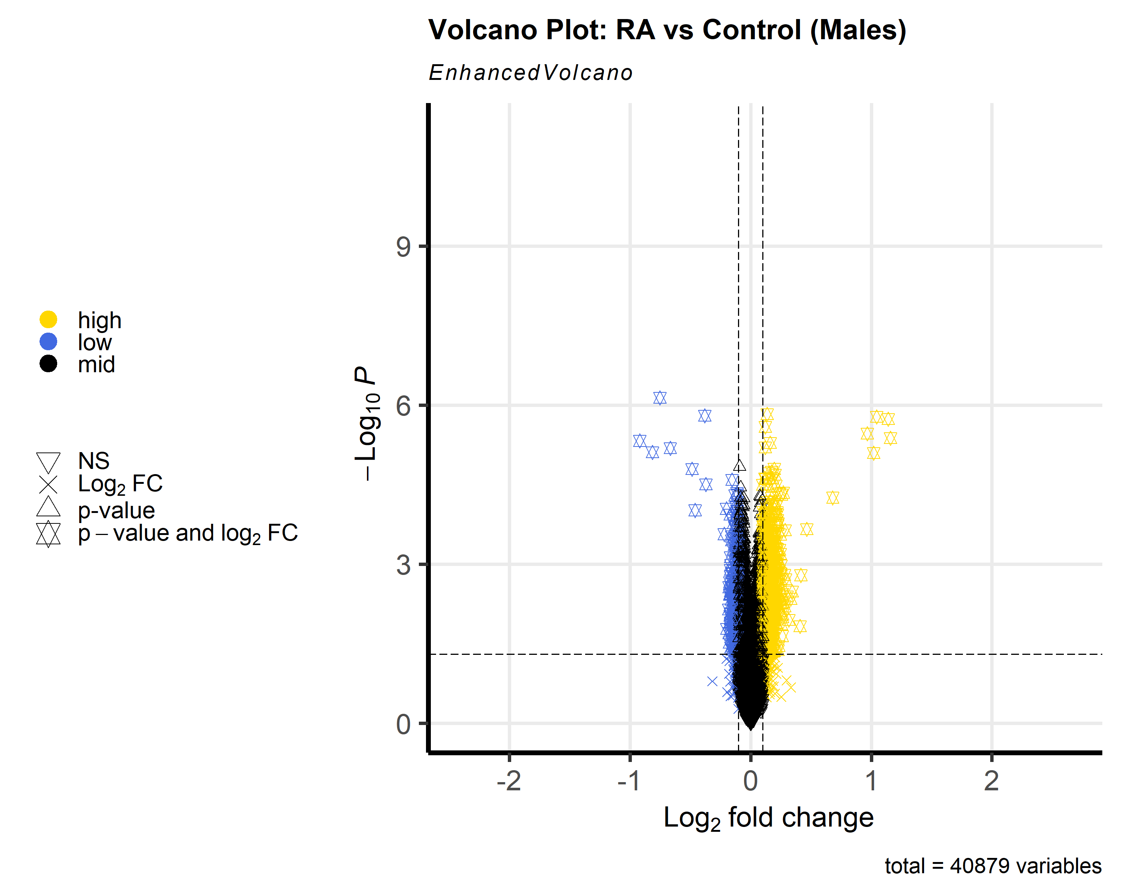

-adjusting color scheme and shape, and location of legend

4.12:

celltype1 <- c("RPS4Y")

celltype2 <- c("XIST")

has_ggalt <- ! is(try(find.package("ggalt")), "try-error")

selectLab = c(if (has_ggalt) celltype1 else NULL, celltype2),

xlab = bquote(~Log[2]~ 'fold change'),

labCol = 'black',

labFace = 'bold',

boxedLabels = TRUE,

shape = 42,

colCustom = keyvals,

colAlpha = 1,

legendPosition = 'right',

legendLabSize = 20,

legendIconSize = 20.0,

# encircle

encircle = if (has_ggalt) celltype1 else NULL,

encircleCol = 'black',

encircleSize = 2.5,

encircleFill = 'pink',

encircleAlpha = 1/2,

# shade

shade = celltype2,

shadeAlpha = 1/2,

shadeFill = 'skyblue',

shadeSize = 1,

shadeBins = 5,

drawConnectors = TRUE,

widthConnectors = 2.0,

gridlines.major = TRUE,

gridlines.minor = FALSE,

border = 'full',

borderWidth = 5,

borderColour = 'black')

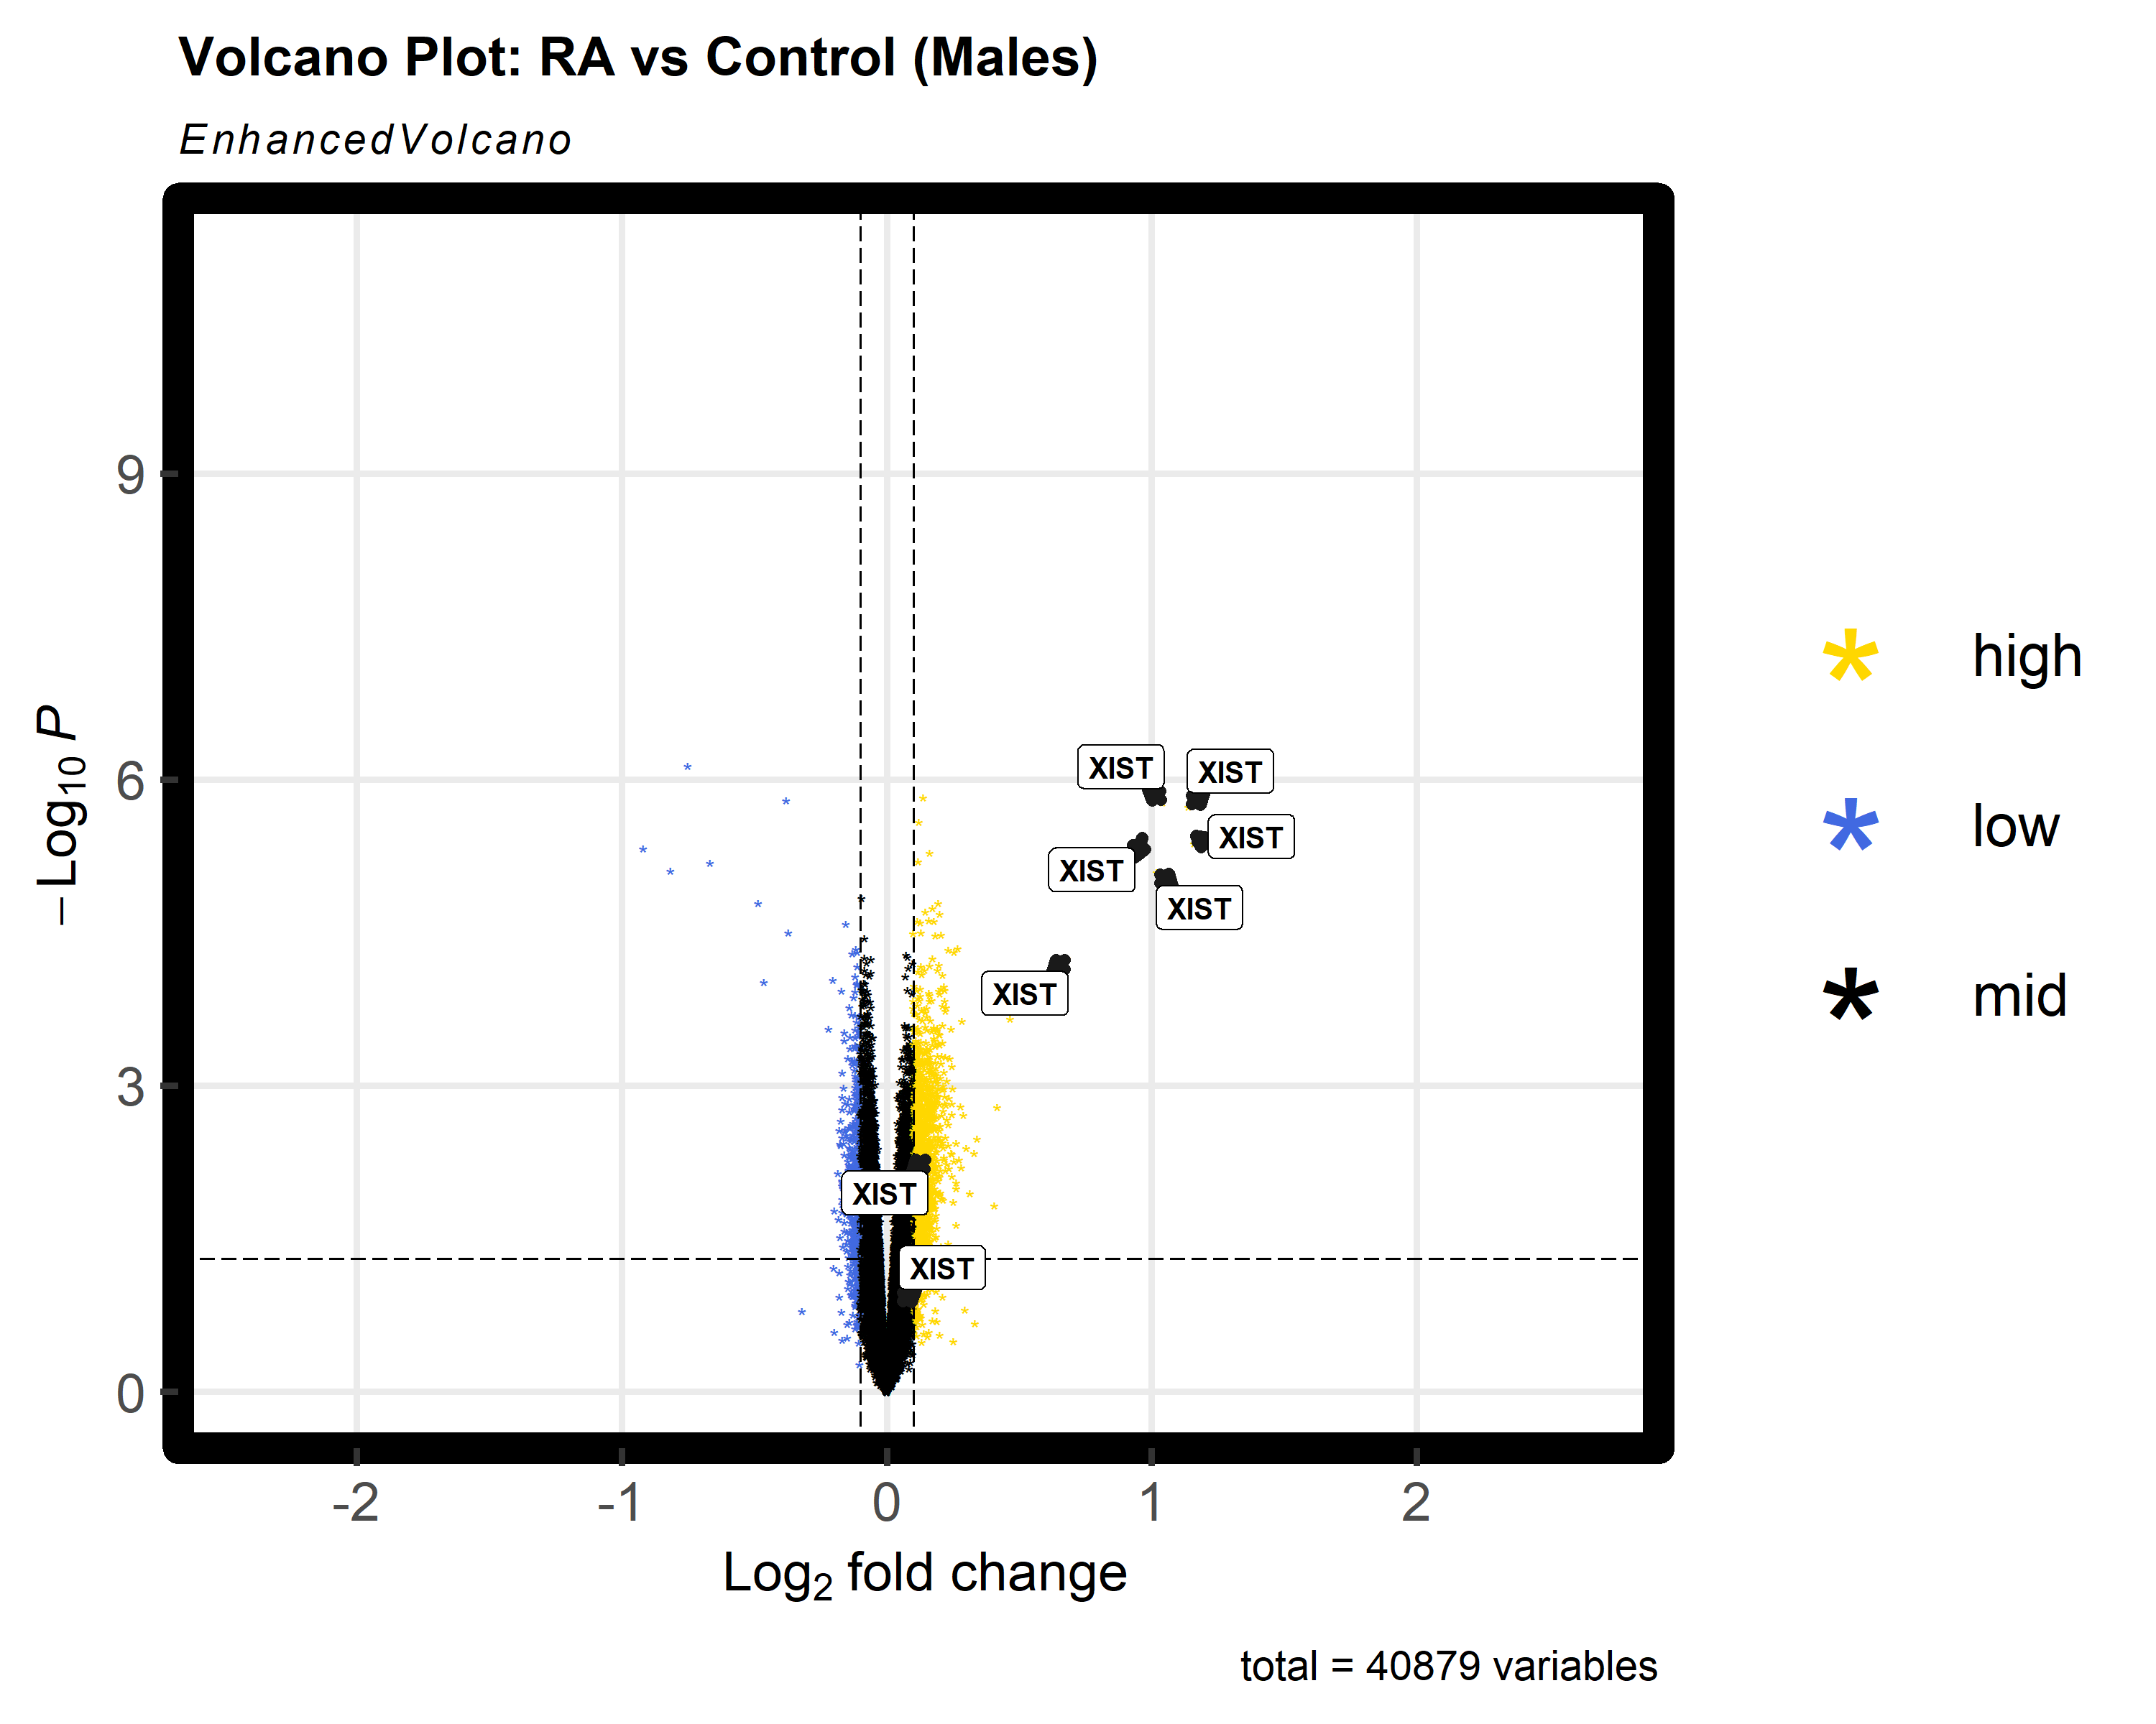

-highlighting certain values, changing legend position and shapes, what is included in legend, boxing gene symbols, and changing color to represent significant genes.

4.14:

colAlpha = 0.9,  
 colGradient = **c**('red3', 'royalblue'),  
 drawConnectors = TRUE,  
 hline = **c**(10e-8),  
 widthConnectors = 0.5)

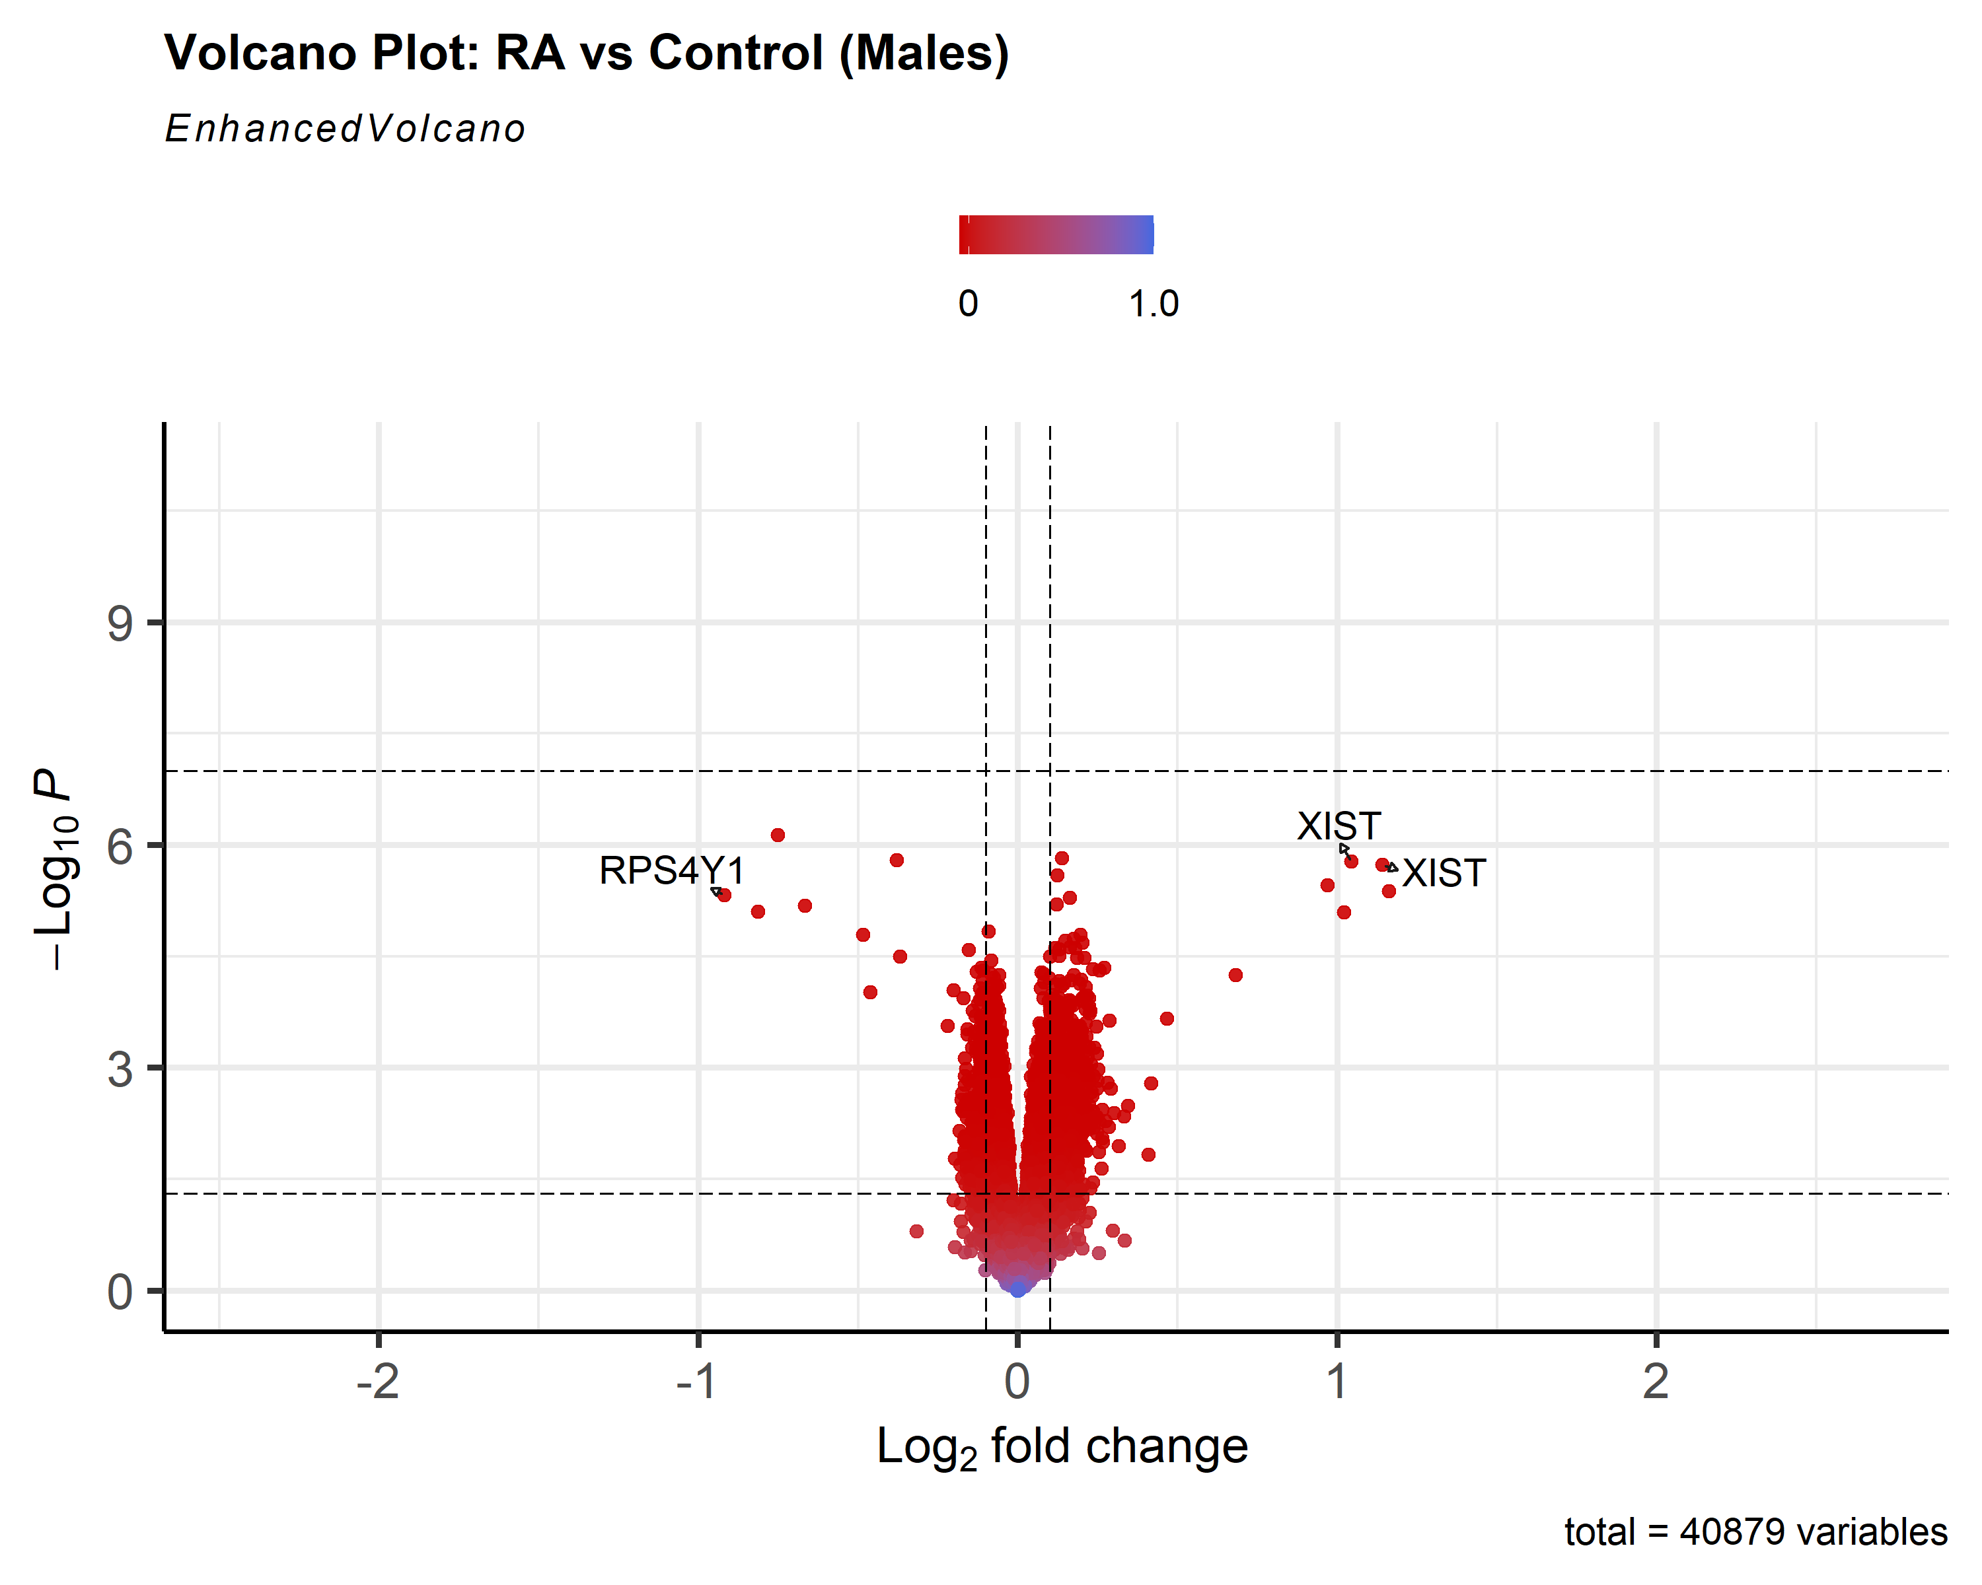

-making a color gradient for a continuous color scheme